As there are 2 instances where the applicant can use Flinks
- 1-To confirm ID. Step 10 (pages 38- 40 in the Interactive PDF)
- 2-To fund their account. Step 14 (pages 56-58 in the Interactive PDF)
we need to make sure we are putting the correct info on the appropriate page/step in the process.

Motive Full DCO Workflow Interactive PDF

Considering the reason for this change is to have the client acknowledge that there will be an automated link between their accounts (Motive account and external FI account) and it will only occur if the client selects Flinks as a funding method, I’d recommend that we make edits to page 56 to add something like “By selecting Next, I confirm that I have read and agree to the Motive Money Transfer Authorization Terms and Conditions, which can be found here.” as static text, on top of the Next/Back Buttons, and provide a link to an updated version of Motive Money transfer Authorization Terms and Conditions form (Mock up below). This will ensure the text will be displayed and acknowledged regardless of which option the client selects (Yes or No), and regardless if they had used Flinks for IDV or not, rather than updating one/both of the Flinks consent pages.

If added to either one of the Flinks consent pages, I believe there would be scenarios where applicants would not be presented with the Terms and Conditions. If added to both, there are scenarios where they would be agreeing to something that they may not be using and agreement is not required.

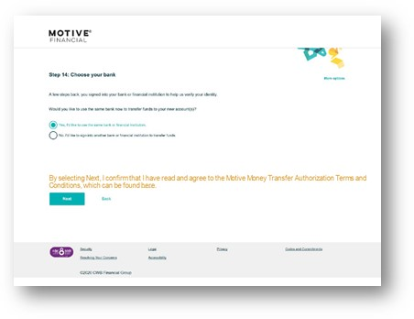
As it relates to what information must be added/provided from the Money Transfer Disclosure Form, Colleen recommended that we discuss with Legal (Soni) as this is form related ie: mock up a proposal, and ask him to review and approve. Lorraine and I had a look at the current form and believe there will need to be updates made to make it work from a digital DCO perspective. I’ve attached the proposed edits in the “money tsf suggested edits..” word doc.

I think there are also edits required on the Flinks Consent Pages (below), but may not be as critical as having the client acknowledge the Money Transfer Authorization Terms and Conditions.

